Testing Suite for the Trie

**Testing whether the Algorithms Work:**

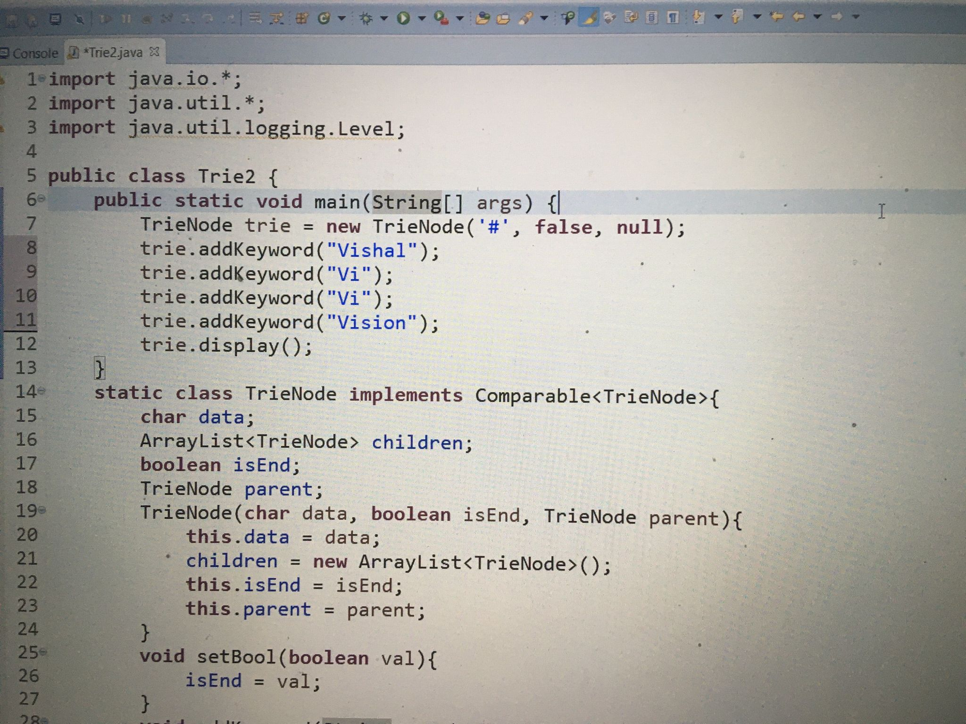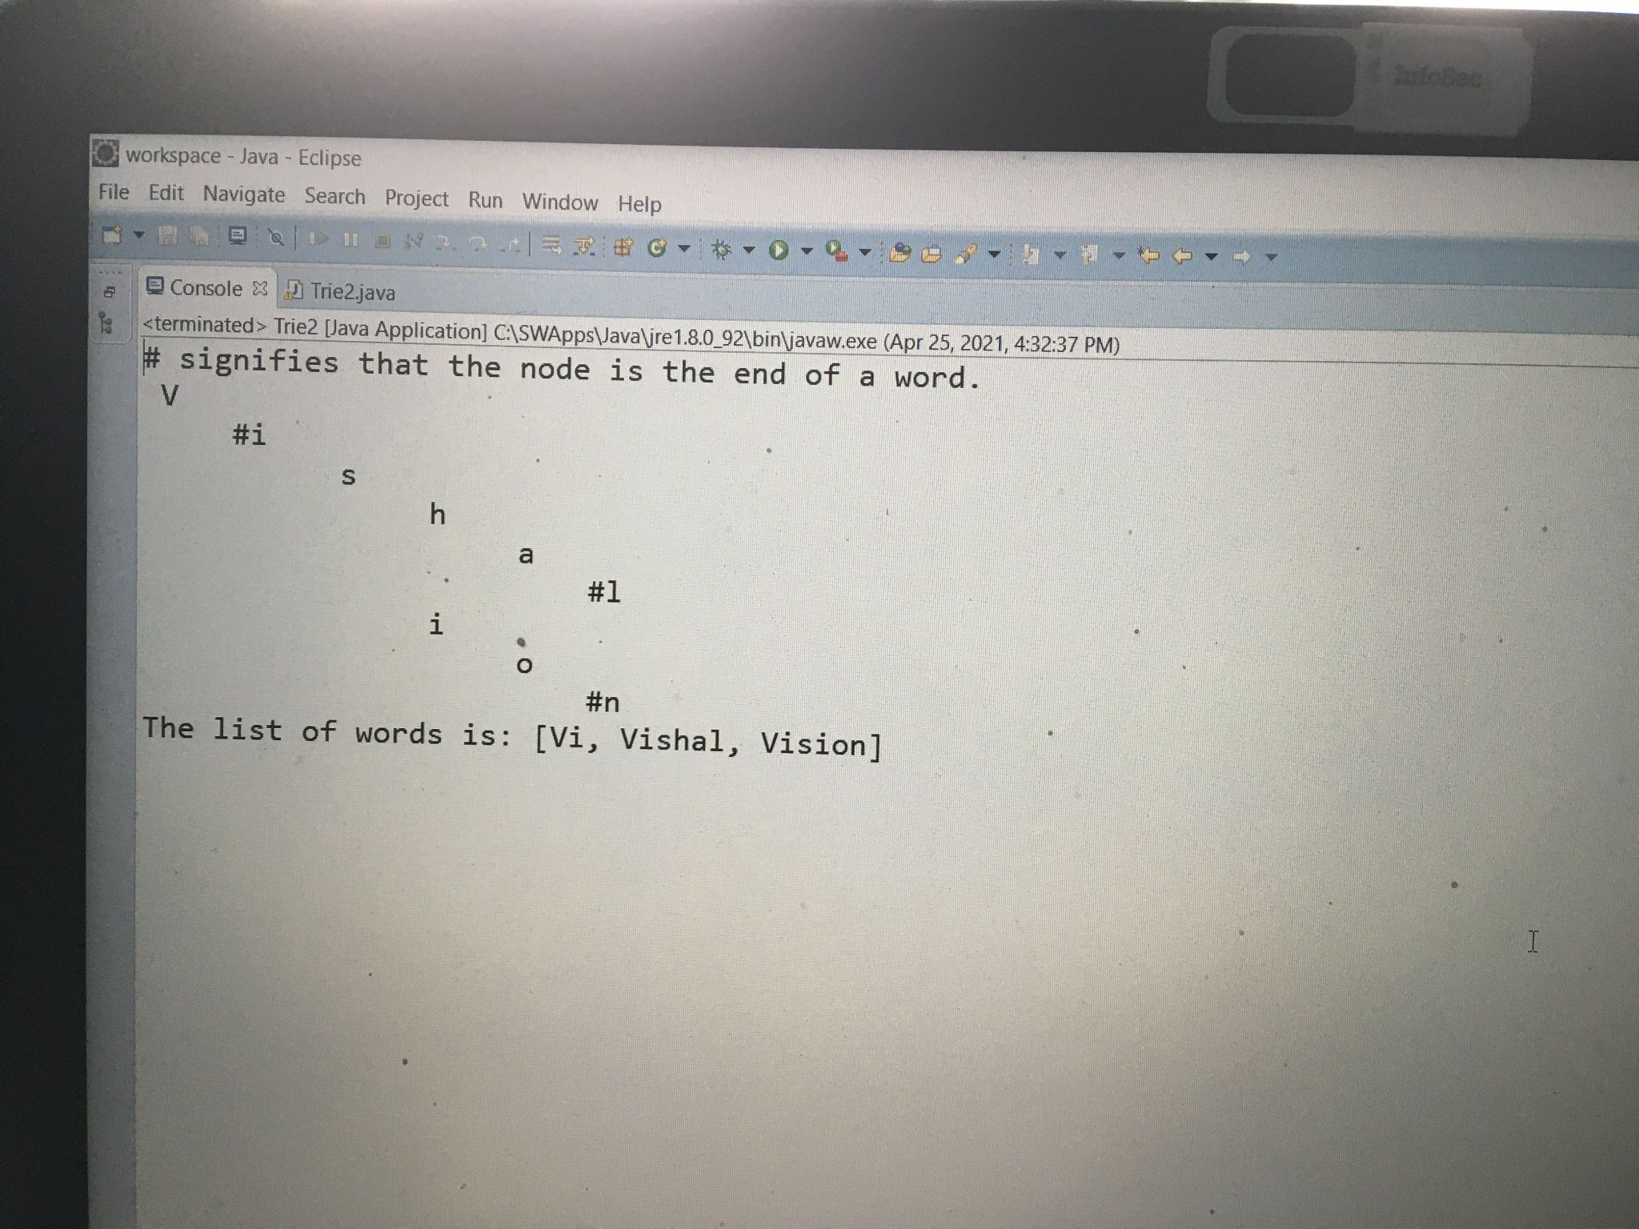

I tested that my display and add methods are working, and the edge case where I try to add the same word twice.

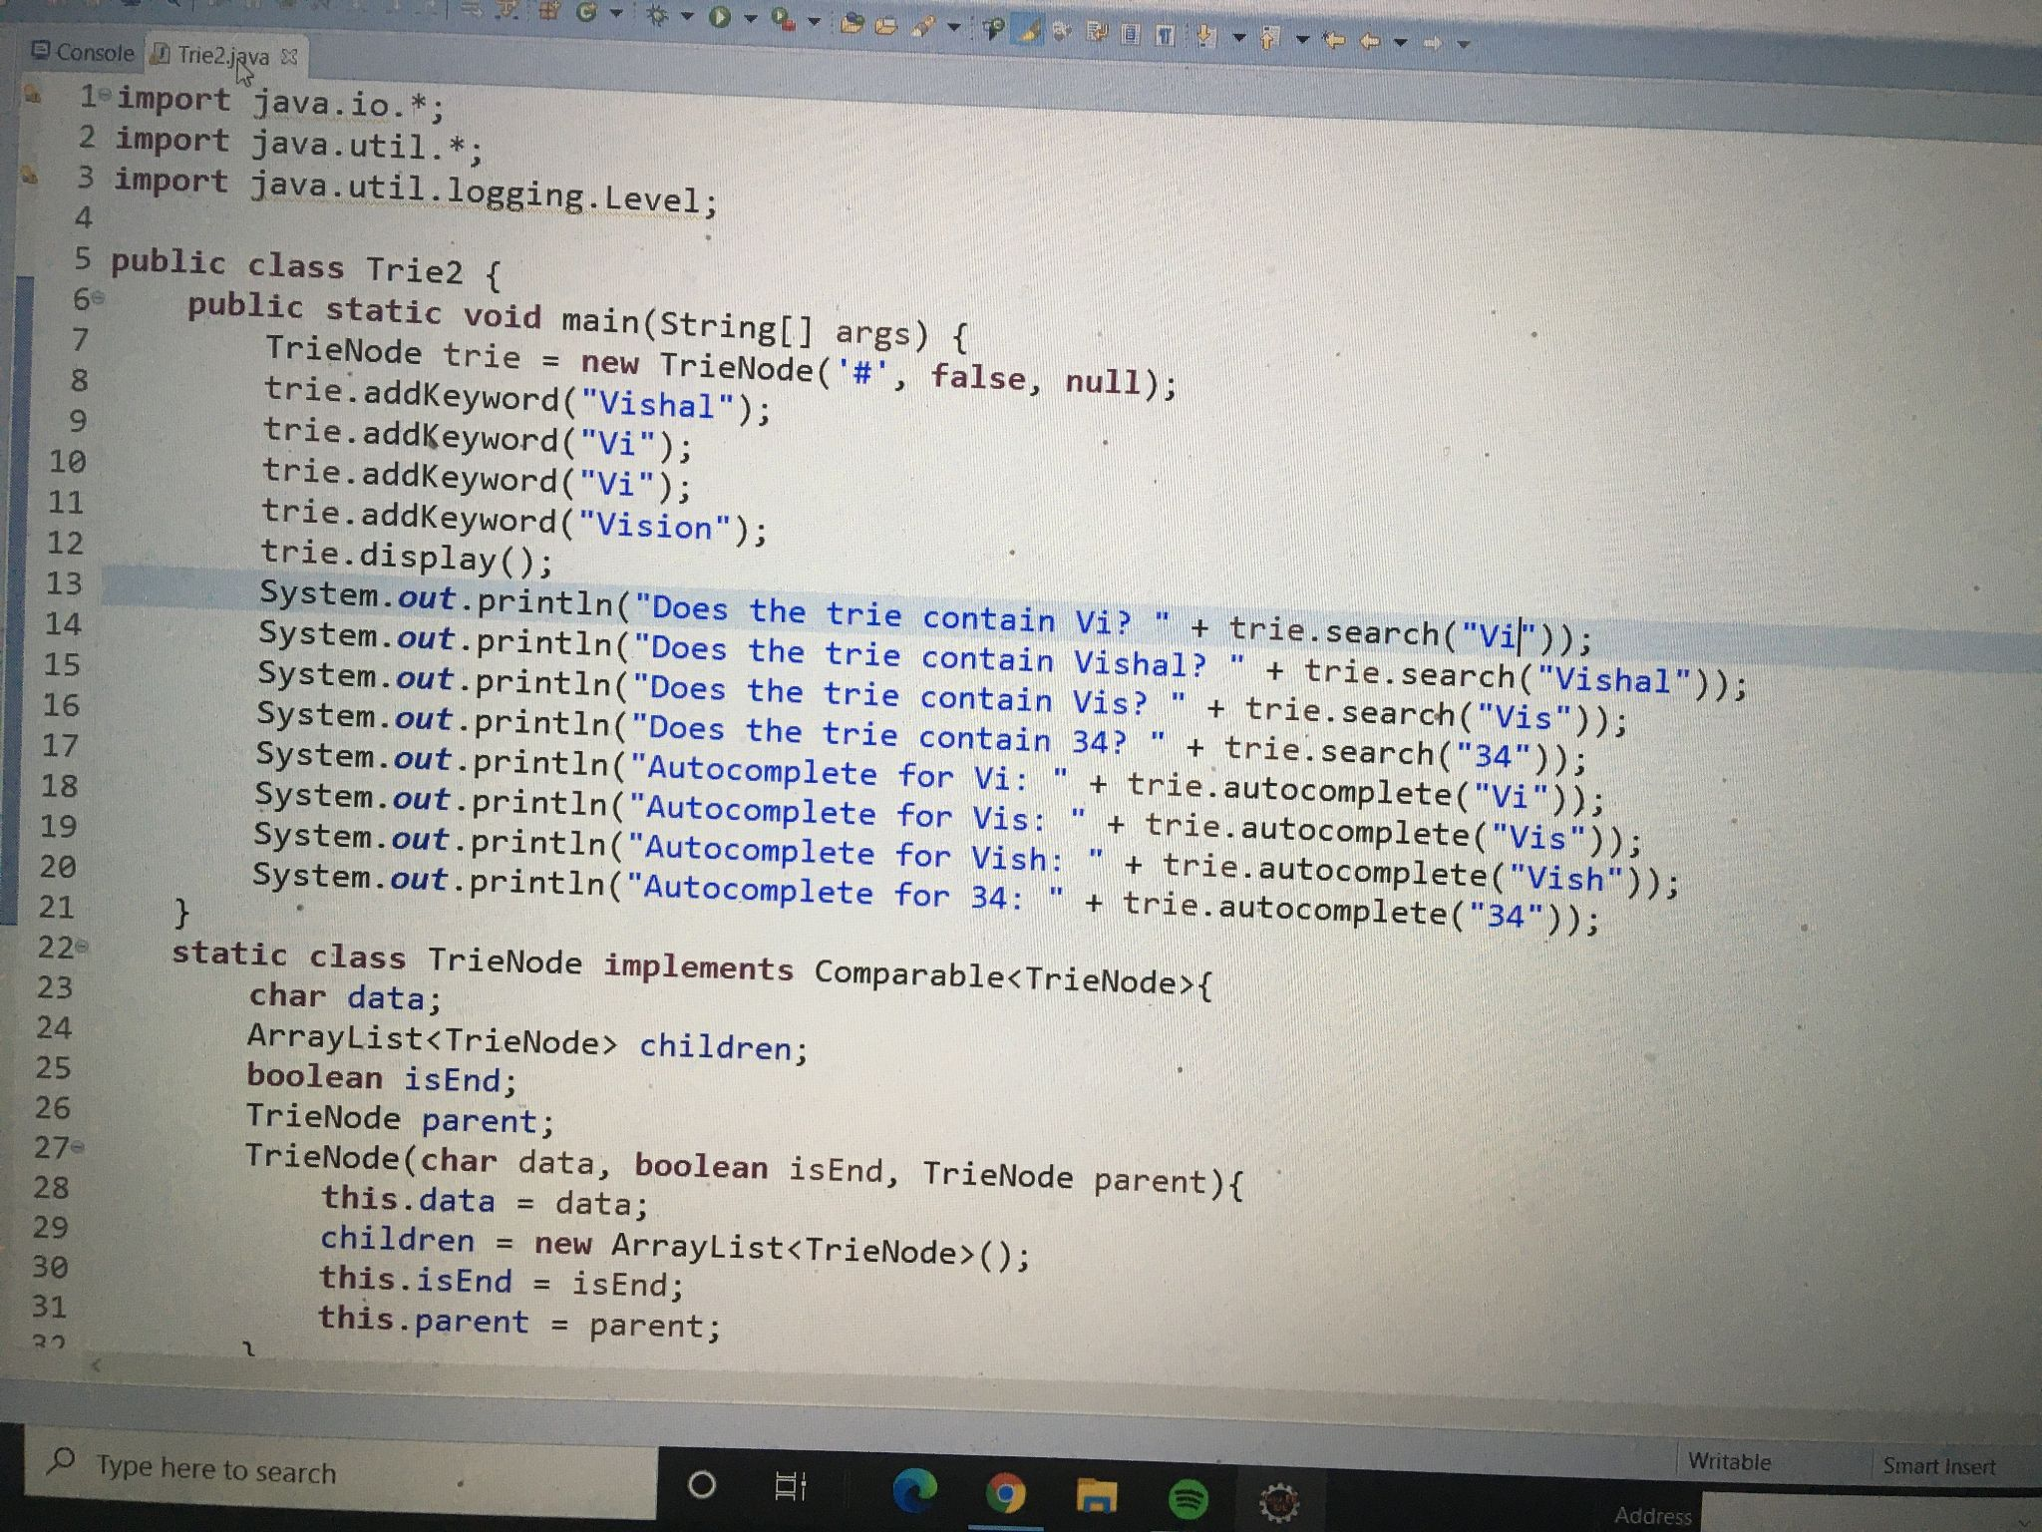

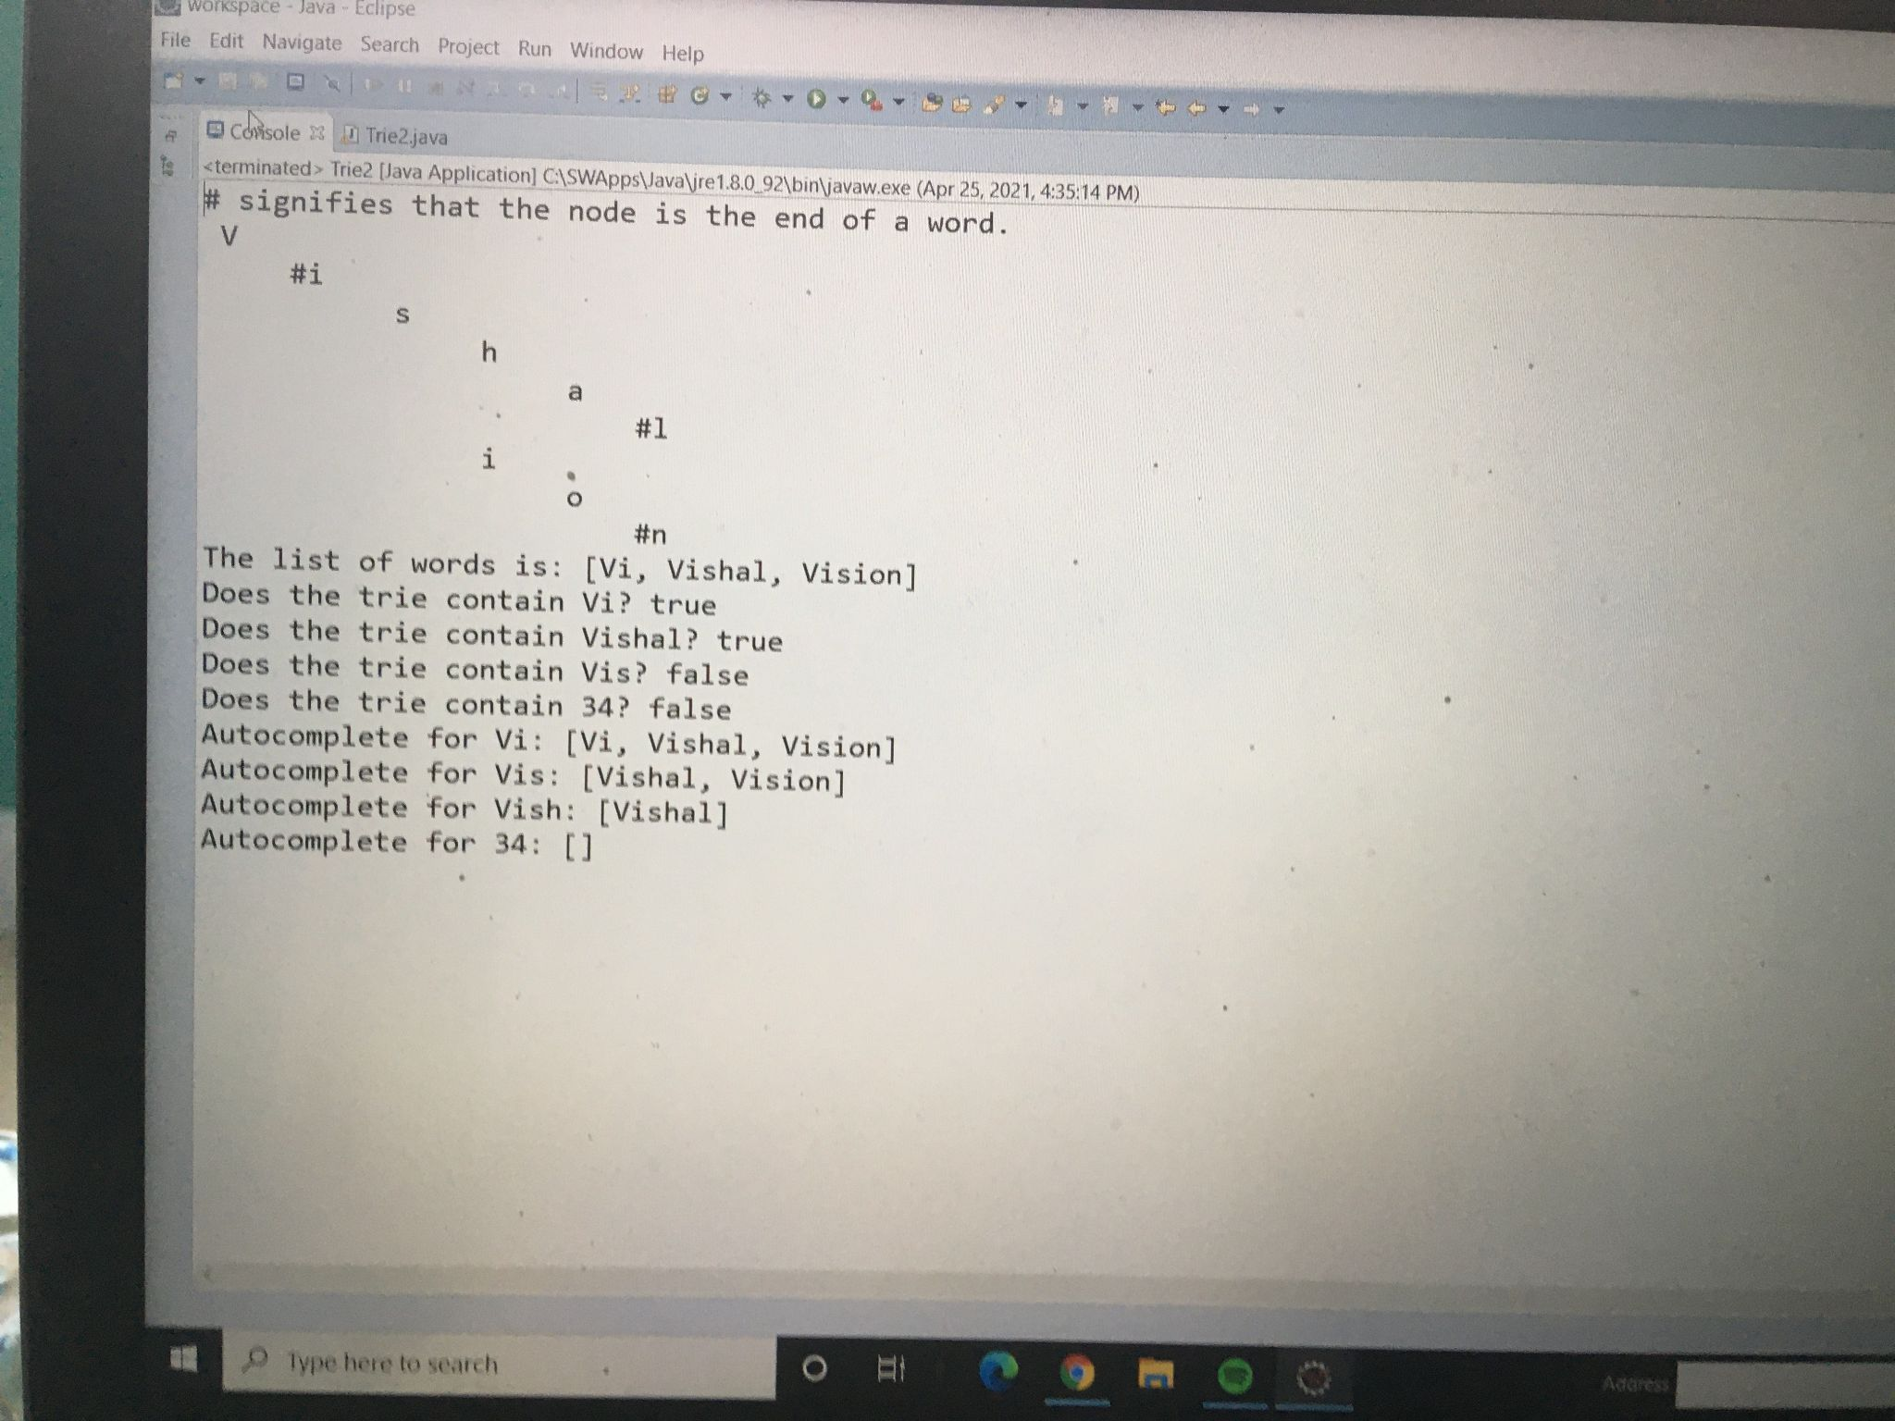

I tested that the search and autocomplete methods are working. Additionally, I tested the edge case that the autocomplete prefix is a word in the trie.

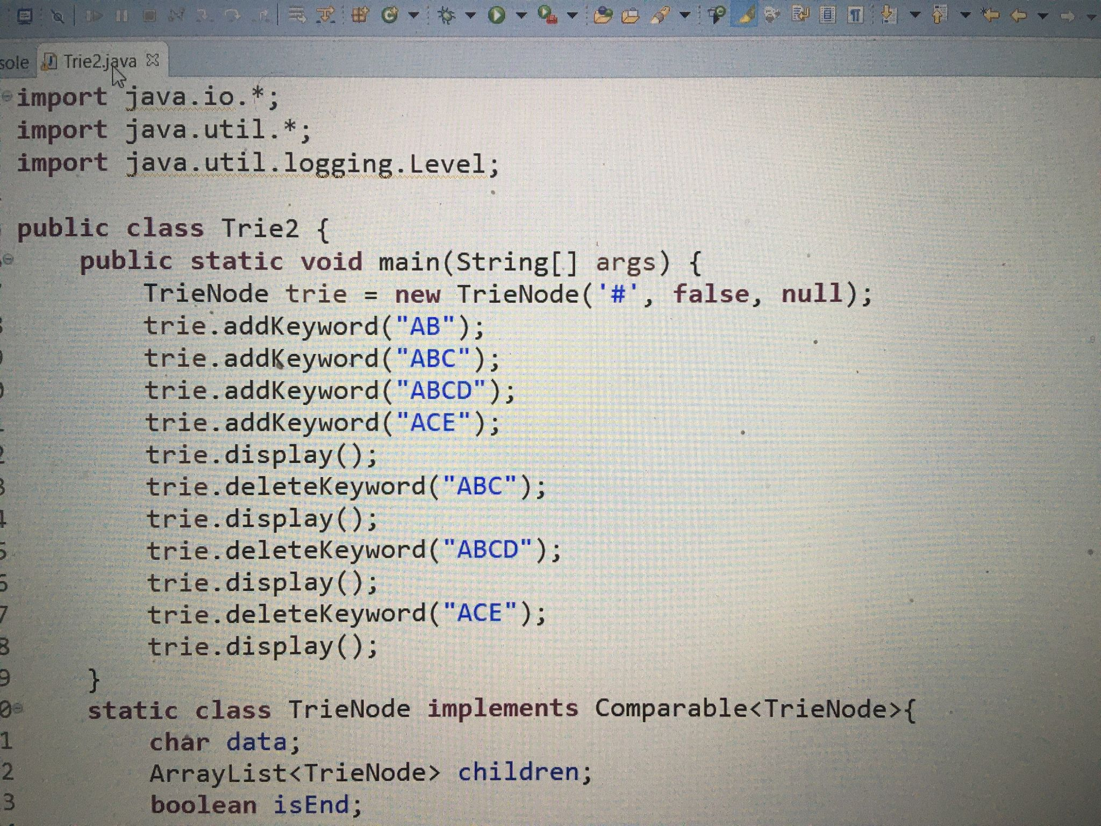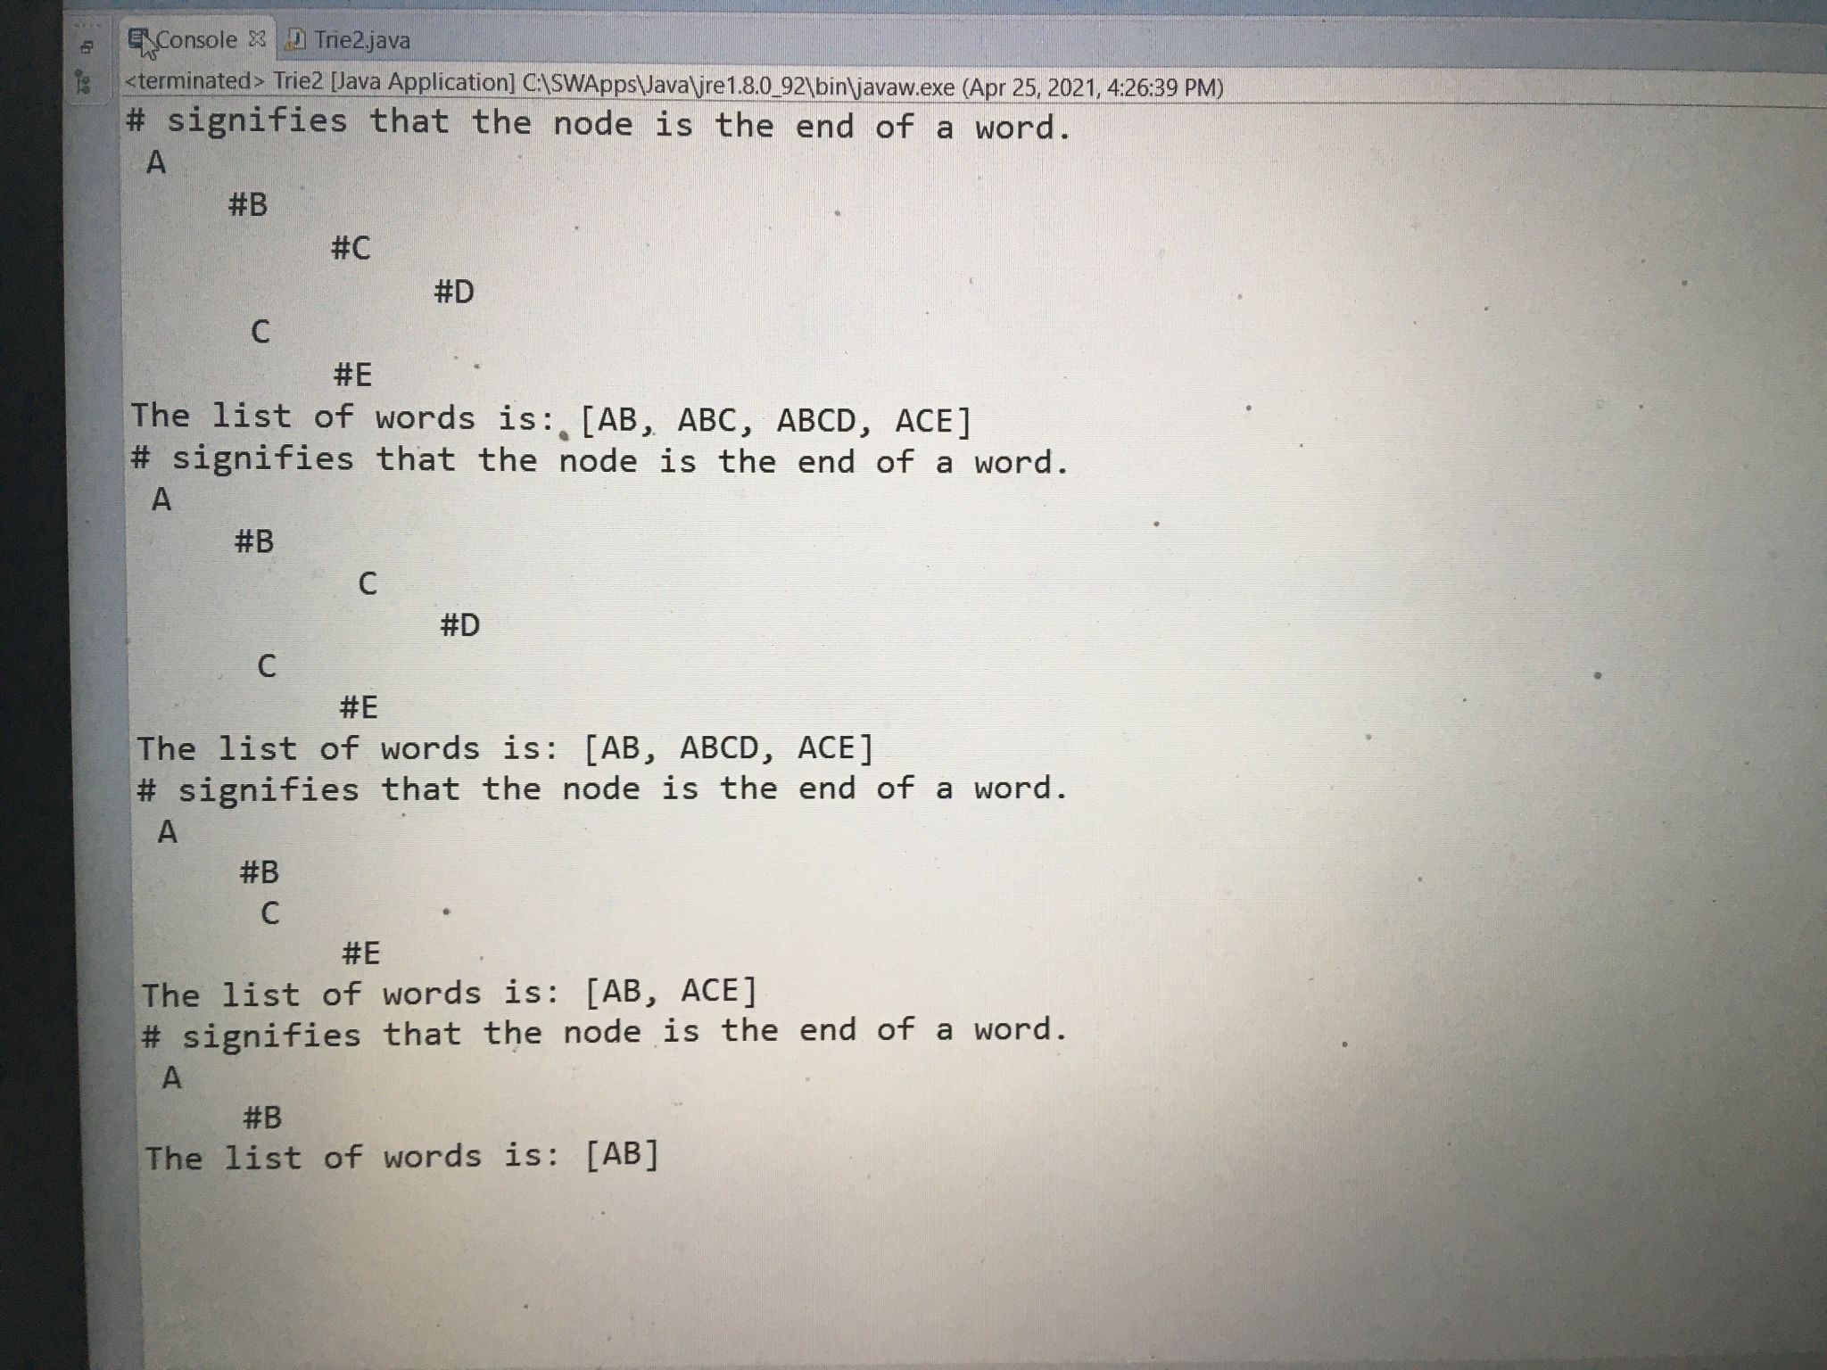

Here, I primarily tested the delete method. First, I tested the case where I remove a word, but there’s another word branching off of that word, to make sure that the word branching off isn’t lost. Then, I tested removing the last word of a branch to make sure that it removes all the characters properly.

**Testing that the Global State works on Windows:**

<https://youtu.be/28PJ1_qdfVA>

Here, I verify that the trie has one global state that can be accessed from multiple clients. First, I displayed the trie, and then added iPhone to the trie. Then, I moved to a different computer, and added Lakers to the trie. Finally, I went back to the original computer and displayed the trie, highlighting how without any commands on that computer from the previous step to the display, a new word was added, showing that the trie had a global state that could be accessed by multiple users.

**Testing that the Global State works for Linux:**

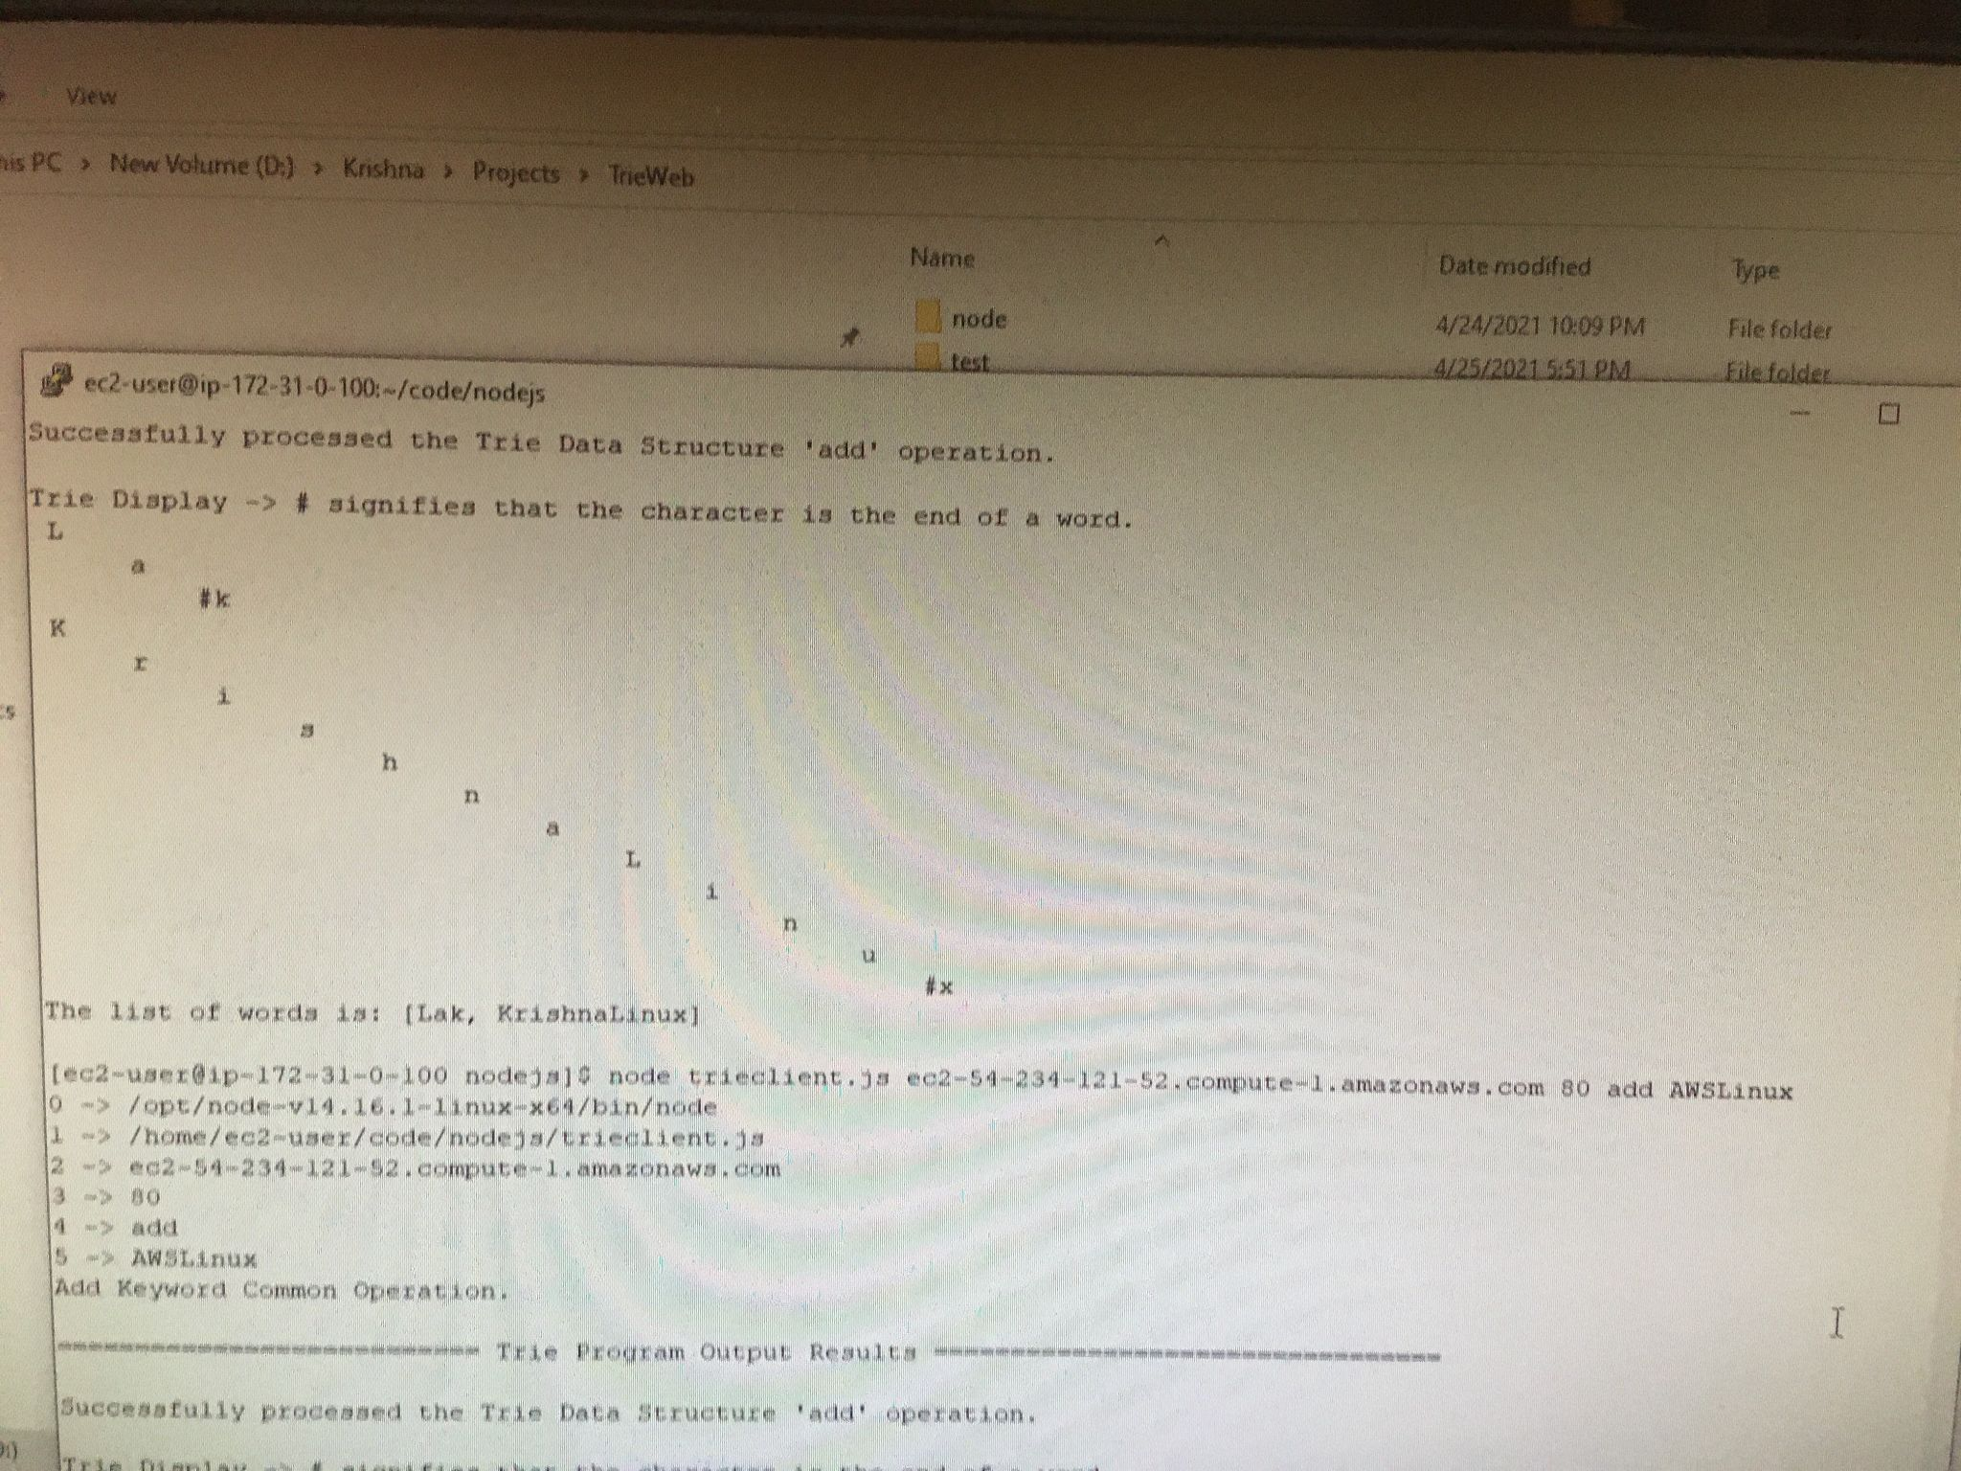

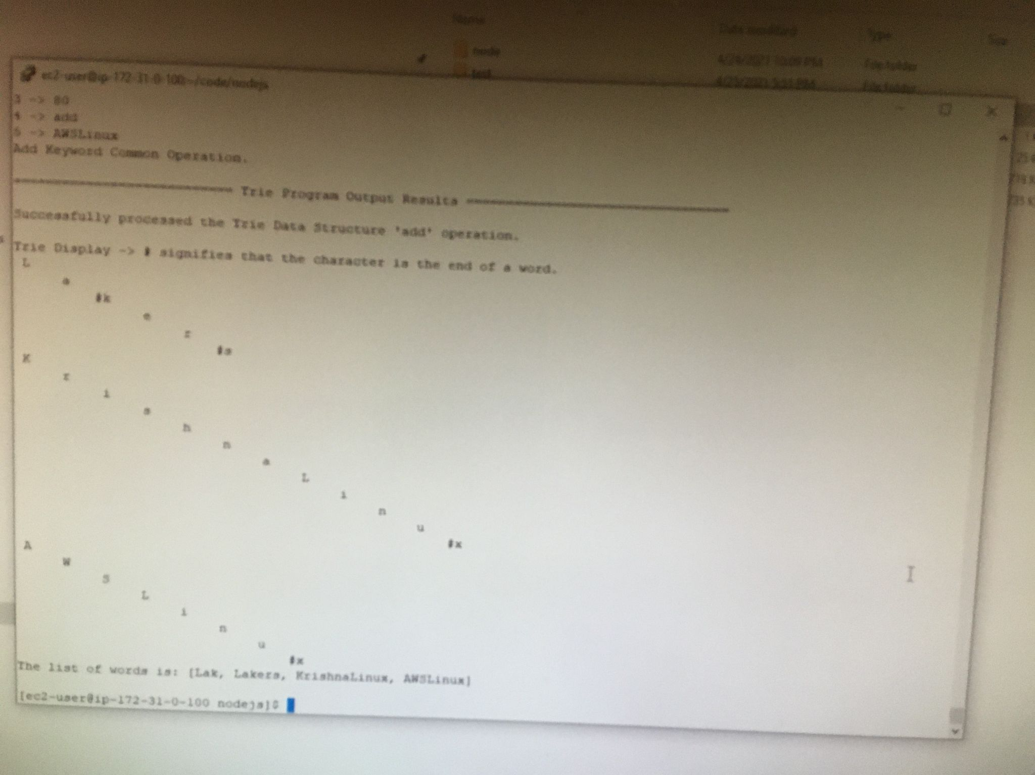

The two screenshots above show me testing the command line interface for Linux using PUTTY and verifying that it works.

**Testing that the Global State works for Mac:**

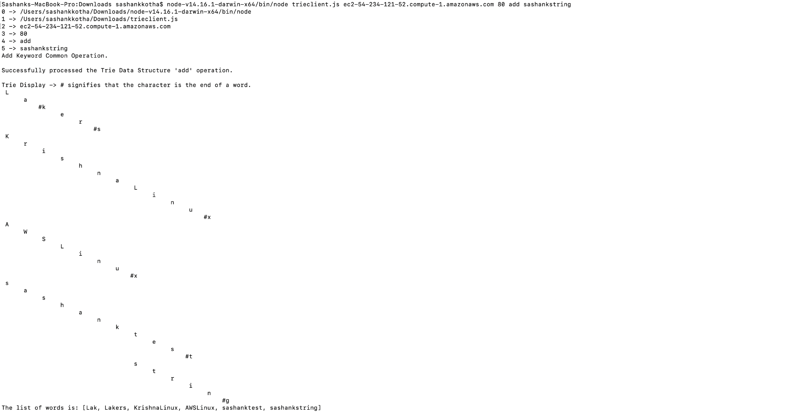

Here, I tested that the commands work on my brother’s Mac. As you can see, the string “sashankstring” was added to the trie.